Resultados Obtenidos
Cargando datos...
Shape train: (82332, 45)
Shape test: (175341, 45)

Distribución de clases en train:
attack_cat
Normal 37000
Generic 18871
Exploits 11132
Fuzzers 6062
DoS 4089
Reconnaissance 3496
Analysis 677
Backdoor 583
Shellcode 378
Worms 44
Name: count, dtype: int64

Distribución de clases en test:
attack_cat
Normal 56000
Generic 40000
Exploits 33393
Fuzzers 18184
DoS 12264
Reconnaissance 10491
Analysis 2000
Backdoor 1746
Shellcode 1133
Worms 130
Name: count, dtype: int64

Clases:
['Analysis', 'Backdoor', 'DoS', 'Exploits', 'Fuzzers', 'Generic', 'Normal', 'Reconnaissance', 'Shellcode', 'Worms']
Columnas categóricas: ['proto', 'service', 'state']
Cantidad columnas numéricas: 39

Entrenando modelo: logistic_regression

================================================================================
Modelo: logistic_regression
================================================================================
Accuracy: 0.7089
Precision M: 0.4373
Recall M: 0.5580
F1 Macro: 0.4257
F1 Weighted: 0.7268

Reporte por clase:
precision recall f1-score support
Analysis 0.04 0.05 0.05 2000
Backdoor 0.05 0.02 0.03 1746
DoS 0.33 0.69 0.45 12264
Exploits 0.81 0.41 0.54 33393
Fuzzers 0.57 0.44 0.50 18184
Generic 0.98 0.98 0.98 40000
Normal 0.91 0.85 0.88 56000
Reconnaissance 0.51 0.58 0.55 10491
Shellcode 0.15 0.75 0.24 1133
Worms 0.02 0.80 0.04 130

accuracy 0.71 175341
macro avg 0.44 0.56 0.43 175341
weighted avg 0.78 0.71 0.73 175341

Entrenando modelo: random_forest

================================================================================
Modelo: random_forest
================================================================================
Accuracy: 0.7456
Precision M: 0.6059
Recall M: 0.4631
F1 Macro: 0.4691
F1 Weighted: 0.7222

Reporte por clase:
precision recall f1-score support

Analysis 0.05 0.01 0.02 2000
Backdoor 0.07 0.14 0.09 1746
DoS 0.34 0.63 0.44 12264
Exploits 0.82 0.54 0.65 33393
Fuzzers 0.73 0.12 0.21 18184
Generic 0.95 0.98 0.96 40000
Normal 0.75 0.99 0.85 56000
Reconnaissance 0.94 0.72 0.81 10491
Shellcode 0.68 0.44 0.53 1133
Worms 0.73 0.06 0.11 130

accuracy 0.75 175341
macro avg 0.61 0.46 0.47 175341
weighted avg 0.78 0.75 0.72 175341

Resultados comparativos:
model accuracy precision_macro recall_macro f1_macro \
1 random_forest 0.745650 0.605855 0.463064 0.469064
0 logistic_regression 0.708921 0.437326 0.558047 0.425720

f1_weighted
1 0.722237
0 0.726762

Mejor modelo según F1 Macro: random_forest
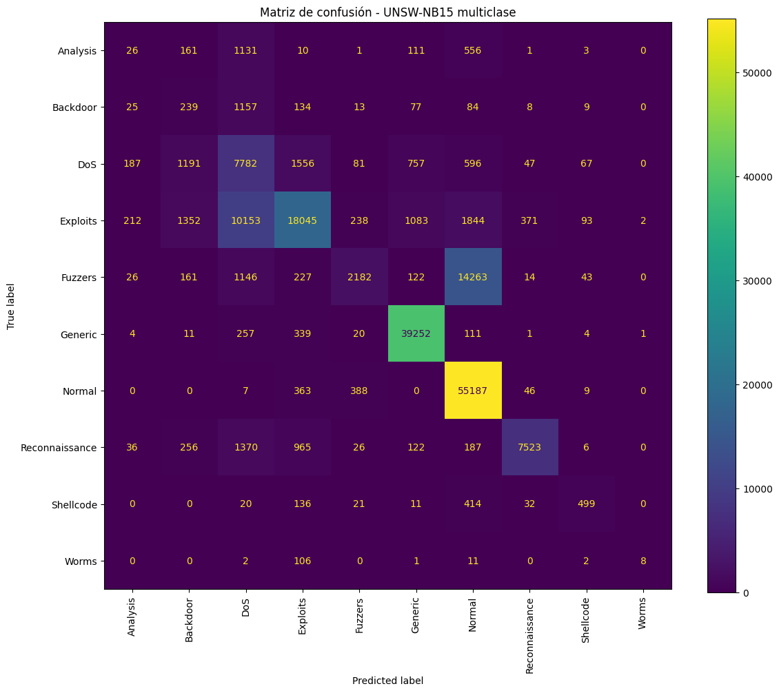
Matriz de confusión guardada en: /content/reports/confusion_matrix.png

Modelo guardado en models/best_model.joblib
Label encoder guardado en models/label_encoder.joblib
Reporte guardado en reports/classification_report.txt

